PART 2.

1. Games:

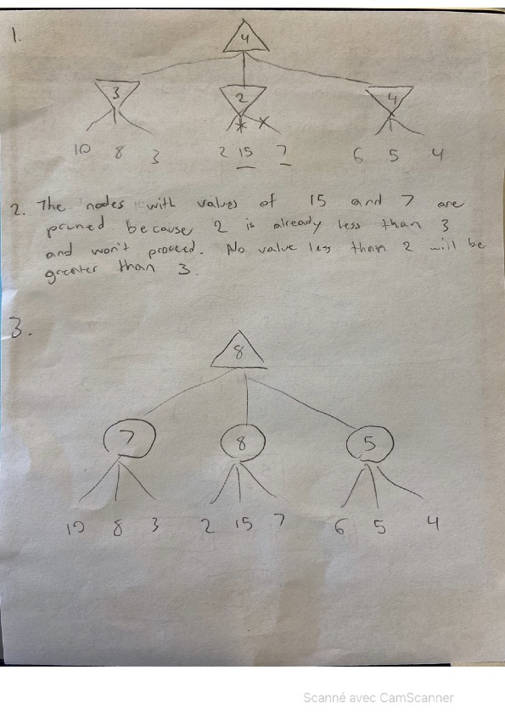

4. No nodes are pruned. Chance nodes take information from all the children nodes to calculate an average, so it is necessary to search all of them.

1. CSPs: Trapped Pacman

1)

Unary:

X2 ≠ P

X3 ≠ P

X4 ≠ P

Binary:

X3 ≠ X2, X3 ≠ X4 | (X2,X3) ≠ (E,E) and (X3,X4) ≠ (E,E)

(X2, X4) = (E,E) or X3 = E

X1 = P | X2 ≠ P

X5 = P | X4 ≠ P

2)

|  |  |  |  |
| --- | --- | --- | --- |
| X1 | P | G | E |
| X2 | P | G | E |
| X3 | P | G | E |
| X4 | P | G | E |
| X5 | P | G | E |
| X6 | P | G | E |

3) The solver can assign 1 and 5 first. They have the most constraints and only have one possible domain which should be satisfied first.

4)

|  |  |
| --- | --- |
| Solution 1 :  {X1 = P, X2 = G, X3 = E, X4 = G, X5 = P, X6 = G} | Solution 2 :  {X1 = P, X2 = E, X3 = G, X4 = E, X5 = P, X6 = G} |